📎 Grenada Cannabis Legalization – Appendices A–E

Prepared by: Jerron Changa Roberts  
Date: April 2025

# Appendix A: Legal Citations & Reform Basis

Includes legal definitions, law references, and draft clauses for legalization.

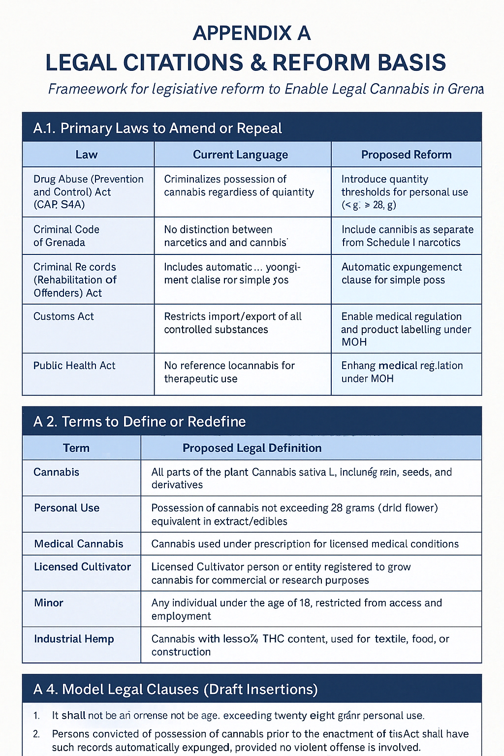

Figure A.1: Legal Foundations and Law Reform Overview

# Appendix B: Public Health & Safety Framework

THC dosage rules, medical use, and youth protection policies.

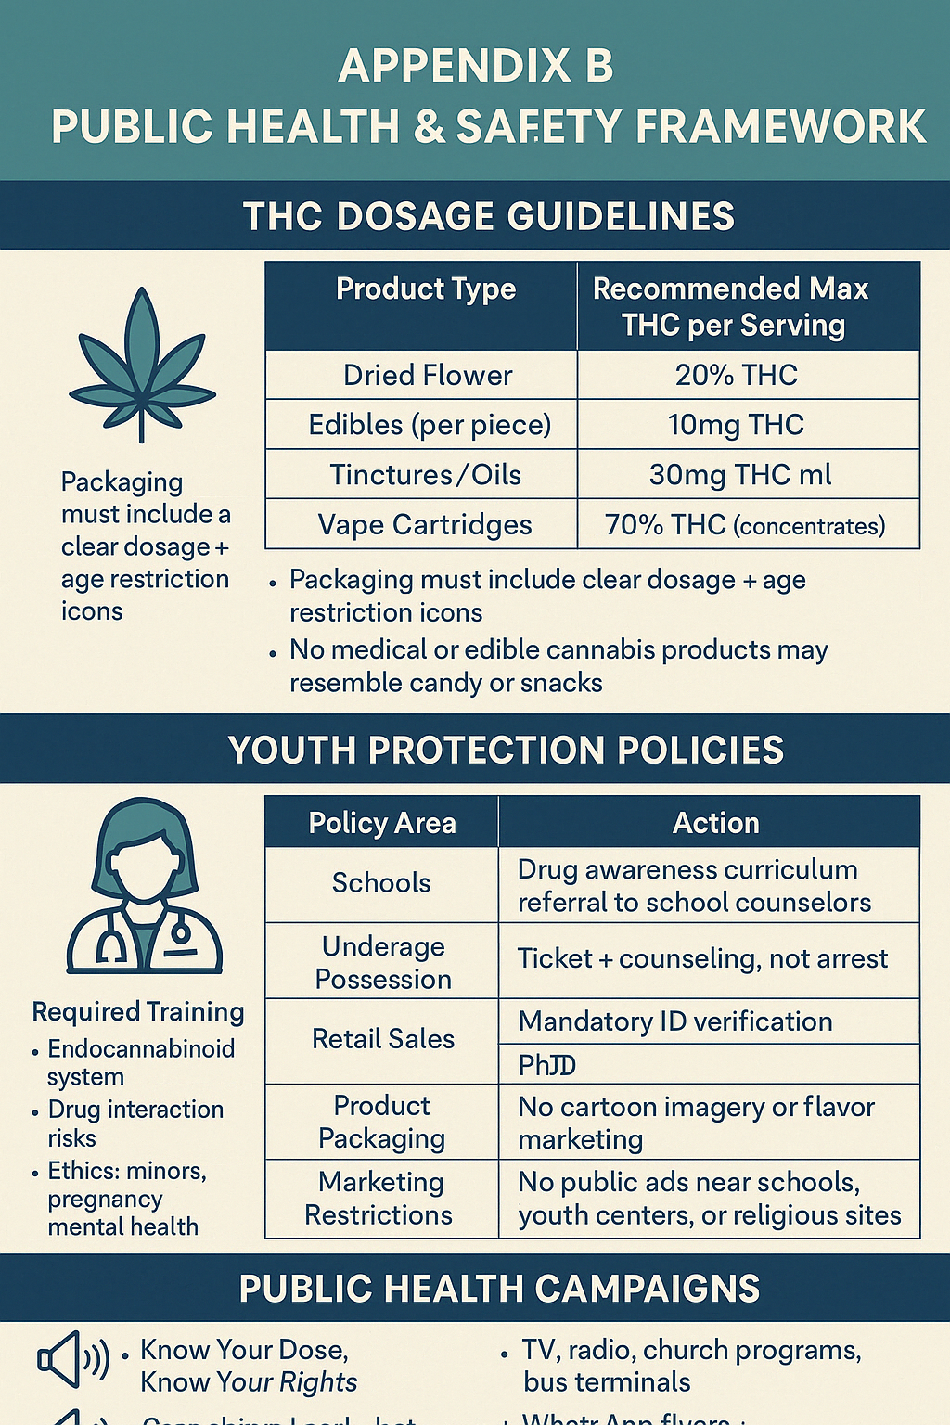

Figure B.1: Public Health Education and Safety Matrix

# Appendix C: Licensing & Compliance Templates

Cannabis license categories, fee structure, and enforcement framework.

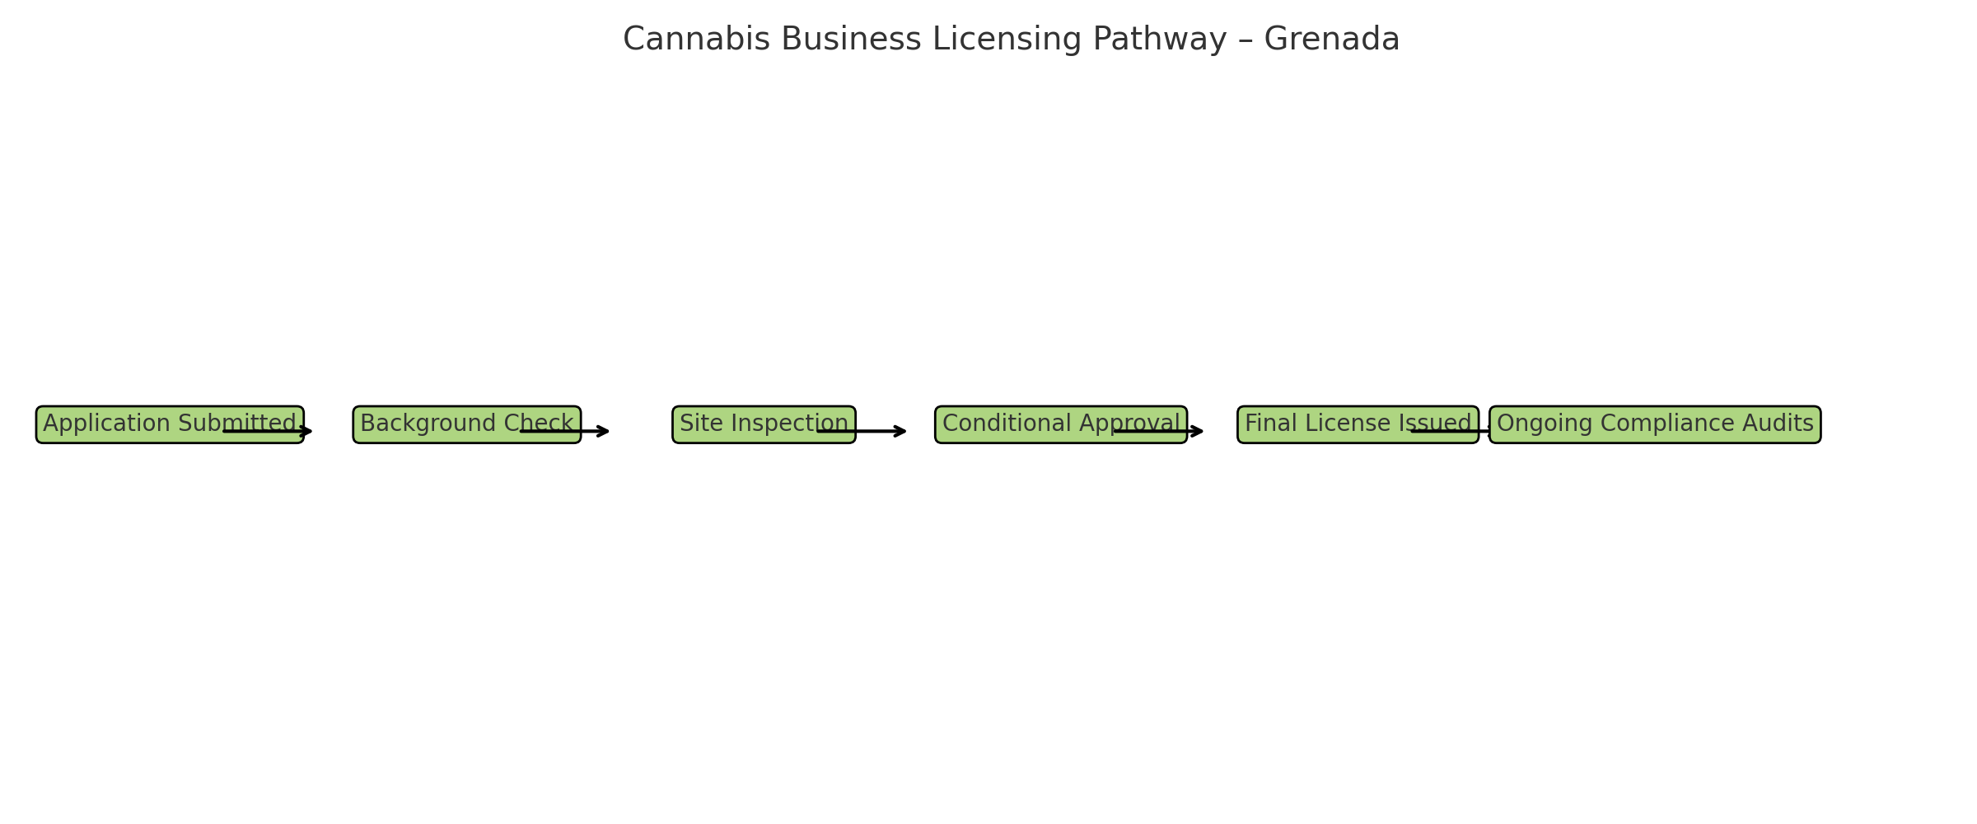

Figure C.1: License Application Flowchart

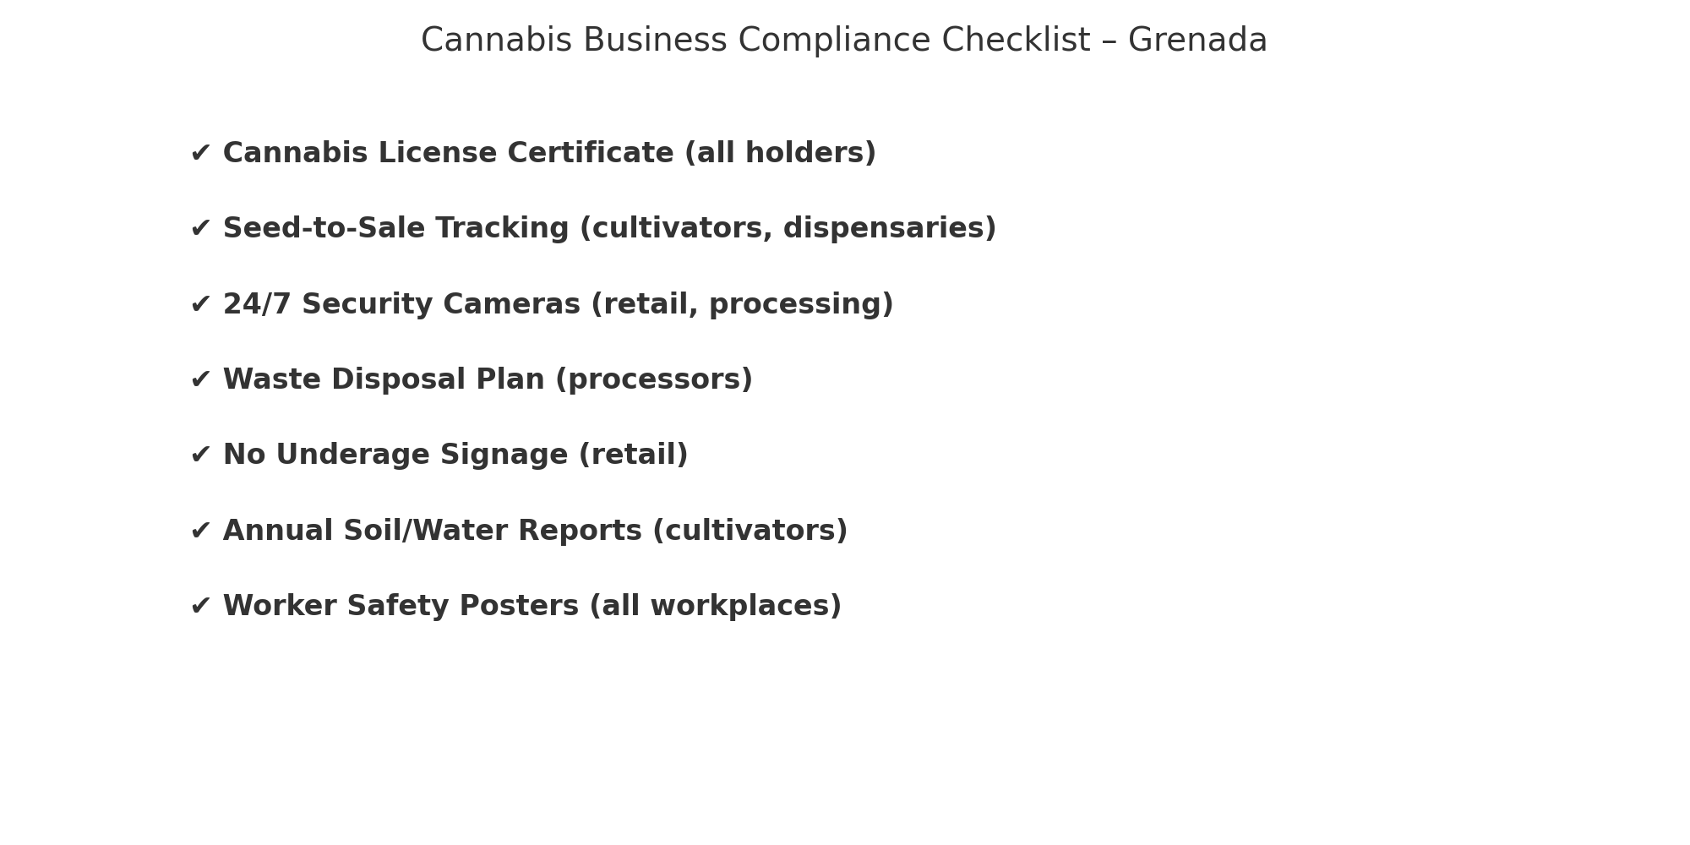

Figure C.2: Compliance Requirement Checklist

# Appendix D: Education & Training Modules

Outlines training content for police, doctors, farmers, and youth workers.

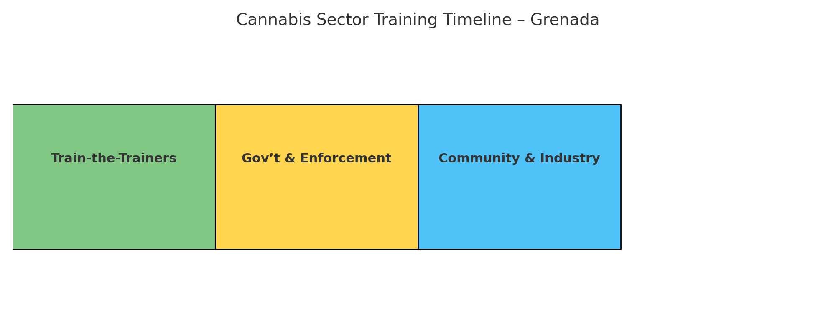

Figure D.1: Sector Training Implementation Timeline

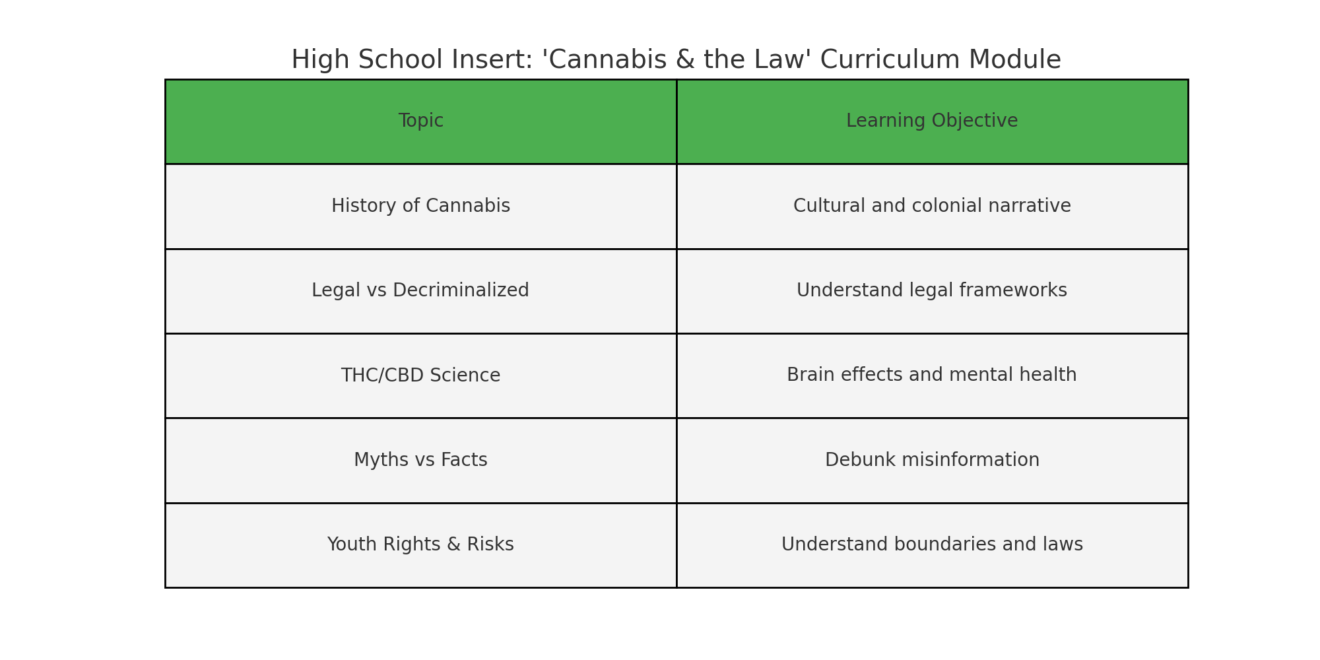

Figure D.2: Curriculum Module Overview for High Schools

# Appendix E: Regional & International Policy Models

Compares Caribbean and global cannabis policies with Grenadian strategy.

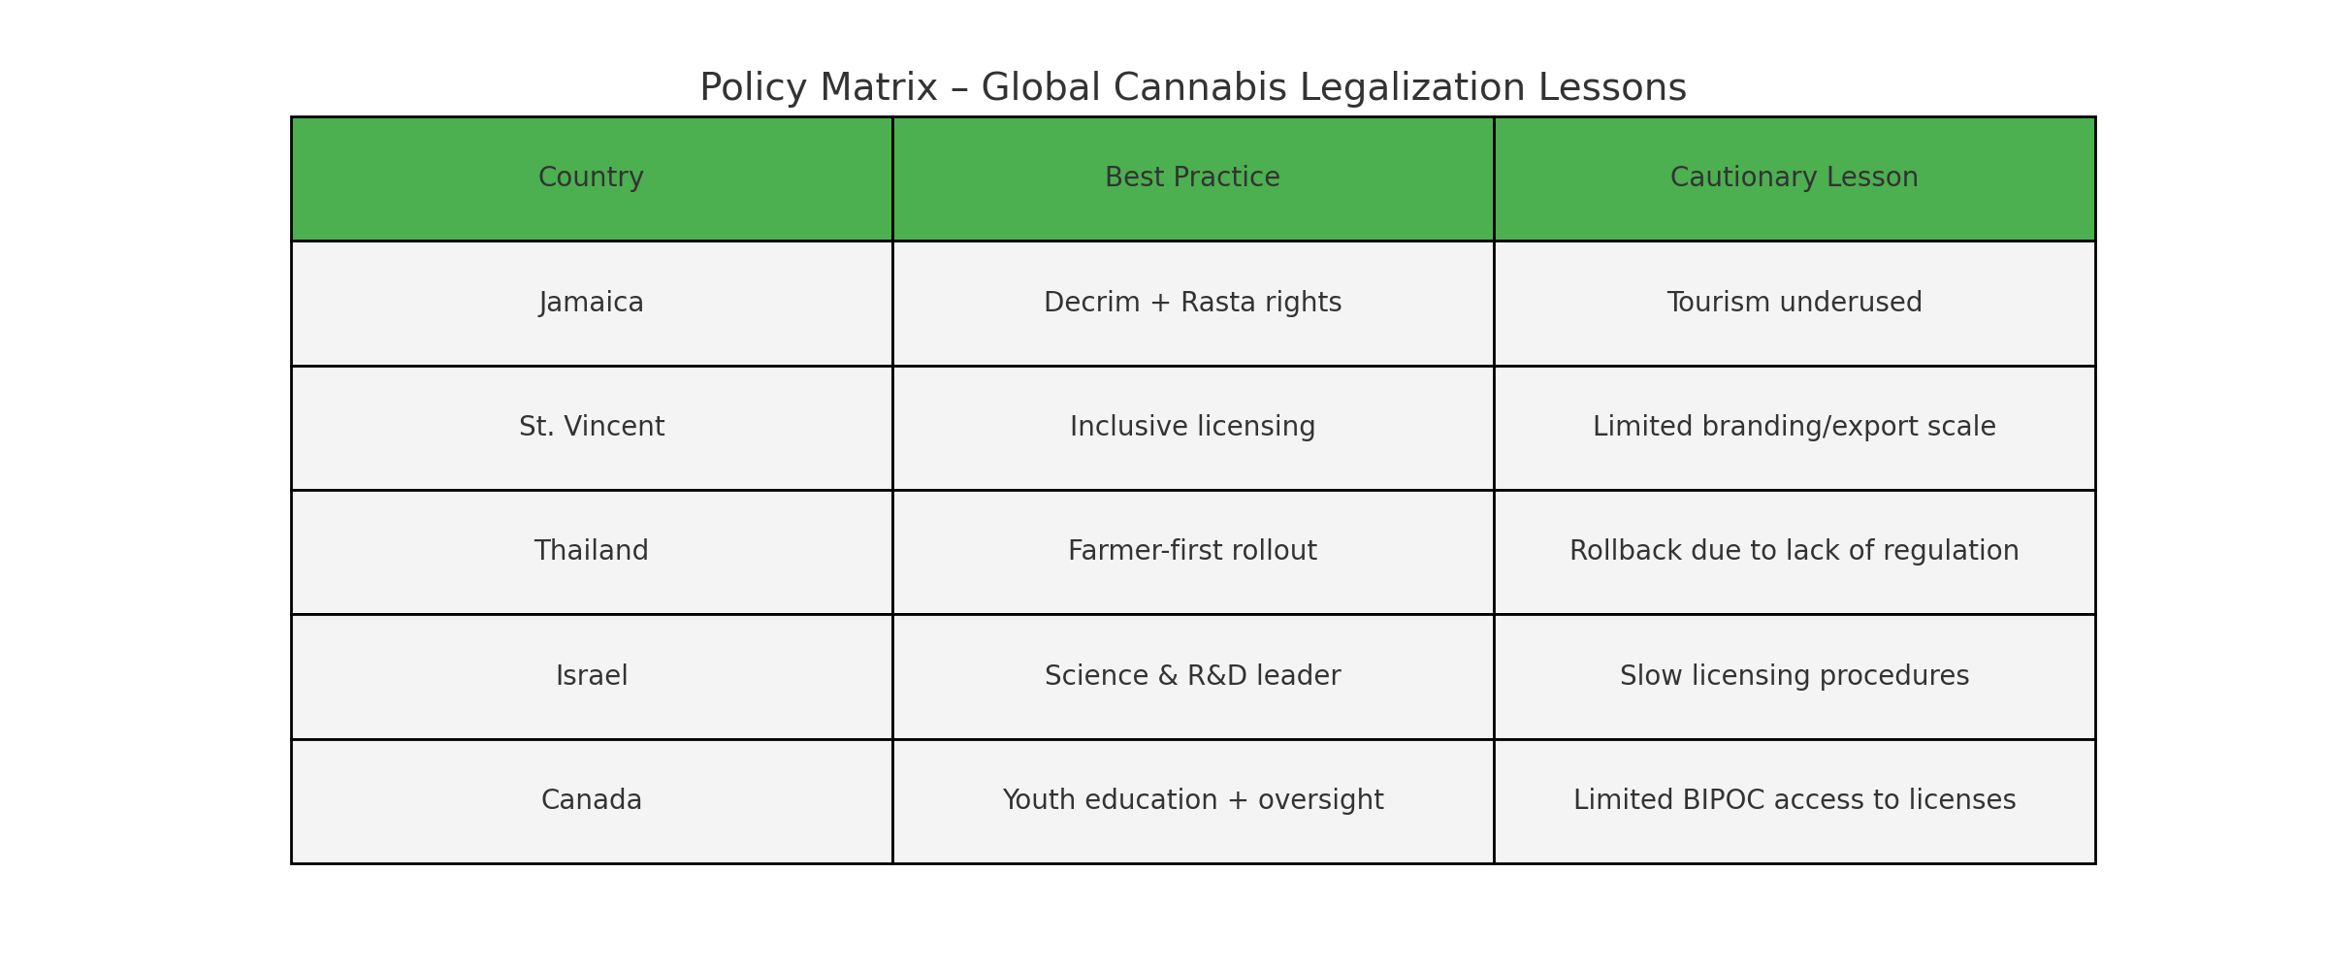

Figure E.1: Global Policy Matrix – Wins and Warnings

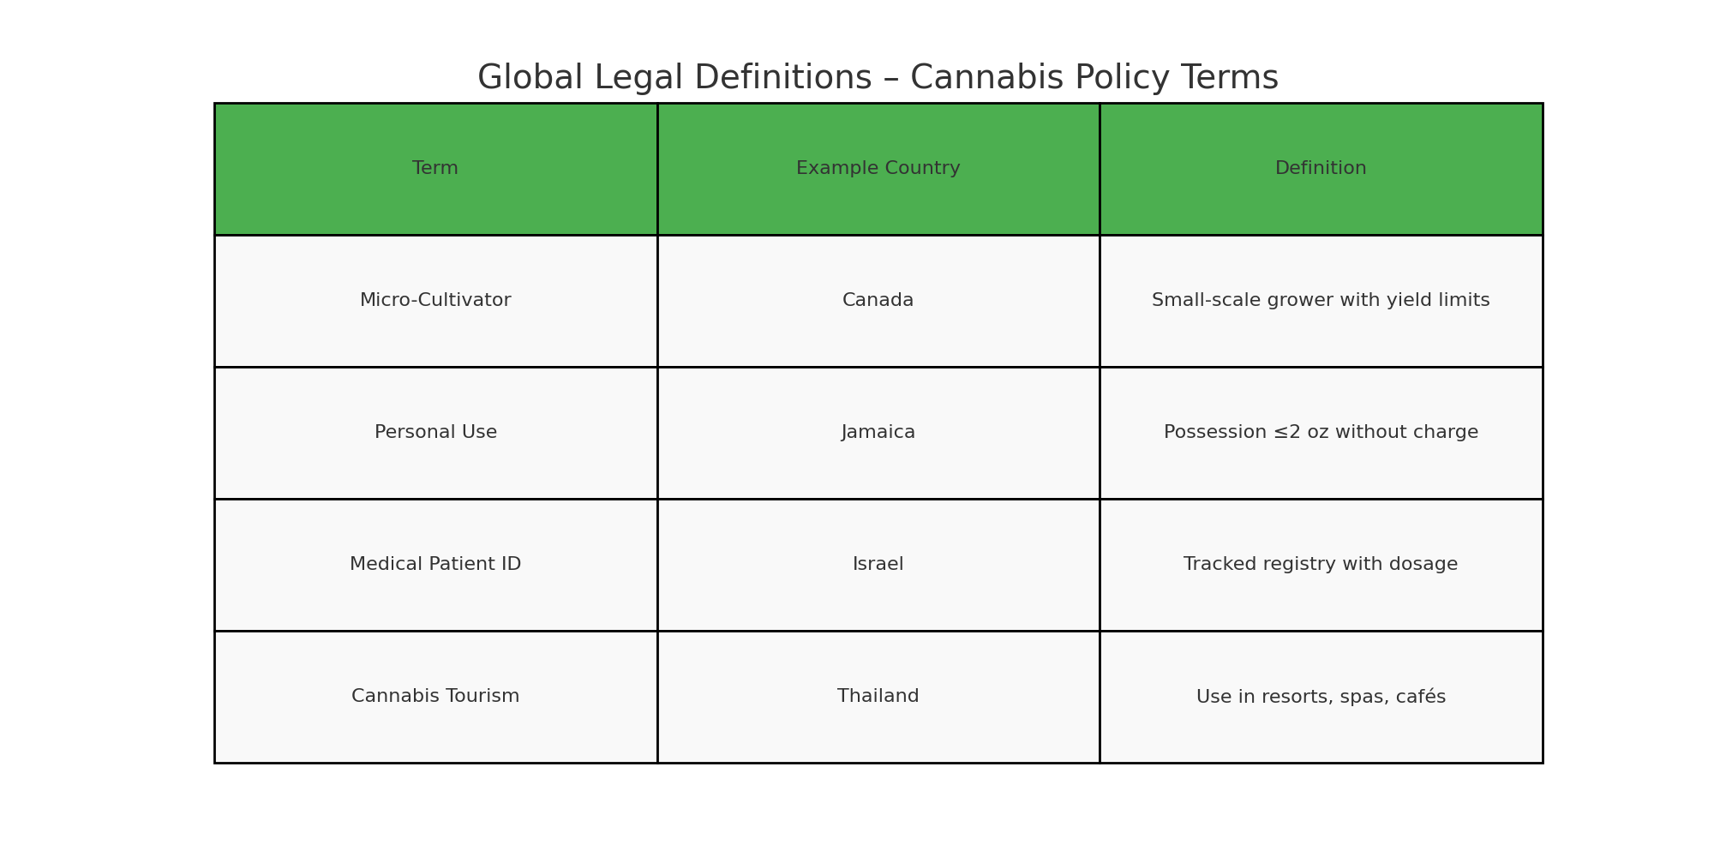

Figure E.2: Global Legal Definitions – Key Terms and Practices